Name and Surname: Naledi Maila
Course: Data Analytics with SQL (April intake)
Student number: 2805001530

Introduction and objective:
Introduction: This project focuses on developing a Retail Sales Data Agent in Databricks capable of analyzing retail sales data and generating accurate, data-driven business insights. The agent is designed to answer analytical questions related to sales performance, customer behavior, profitability, inventory trends, and operational efficiency while ensuring that all responses are based strictly on the provided dataset.

Objective: The objective of this project is to build an intelligent retail analytics agent that can efficiently analyze retail sales data, identify trends and patterns, generate actionable insights, support business decision-making, and provide reliable responses without fabricating or assuming information that is not present in the dataset.

Dataset Description
The retail sales dataset contains 1,000 transaction records and 9 columns that capture customer purchases, product information, and sales performance data. The dataset is designed for retail analytics and can be used to analyze customer behavior, sales trends, profitability, and product performance.
Below are columns included in the dataset:
- Transaction ID – Unique identifier for each sales transaction.
- Date – The date when the transaction occurred.
- Customer ID – Unique identifier assigned to each customer.
- Gender – Gender of the customer making the purchase.
- Age – Age of the customer.
- Product Category – The category of products purchased (e.g Beauty, Clothing, Electronics).
- Quantity – Number of items purchased in the transaction.
- Price per Unit – Cost of a single product unit.
- Total Amount – Total transaction value calculated from quantity and price.

Step 1
Uploading Data on Databricks screenshot
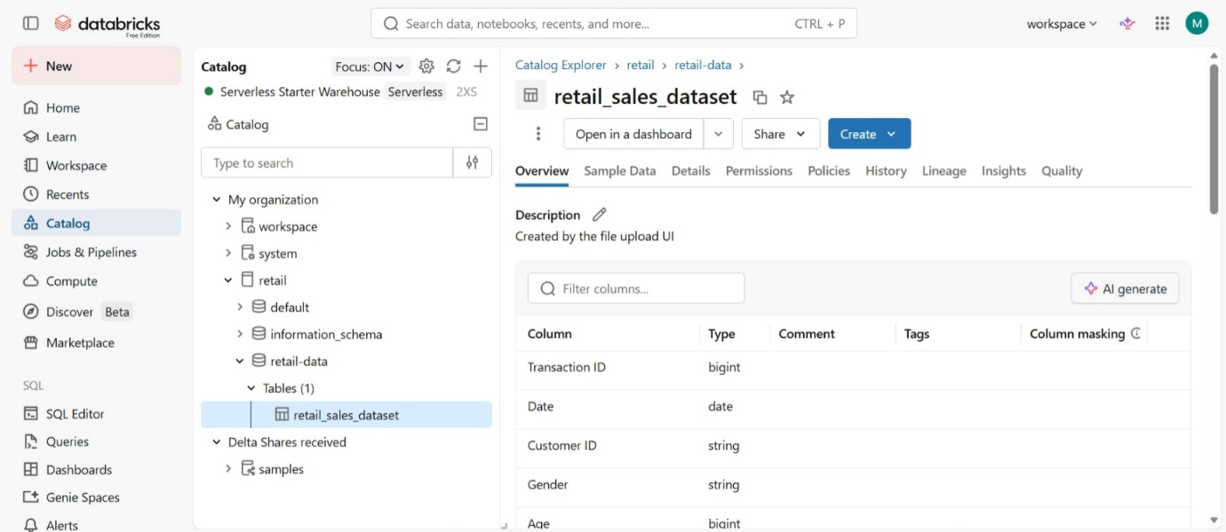
Step 2
Dataset Preview on Databricks Screenshot
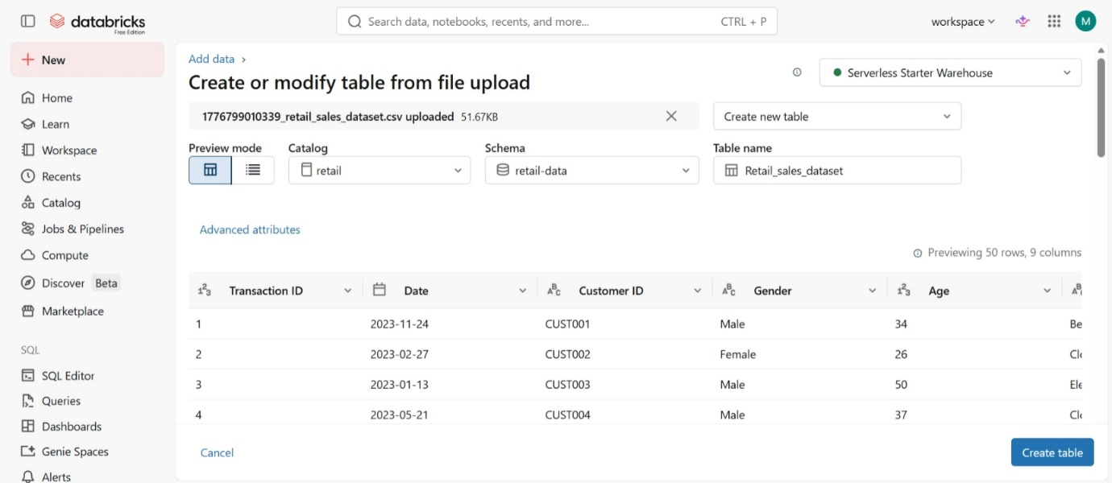

Step 3
Dataset location on Databricks Screenshot

Step 4
Data agent setup page
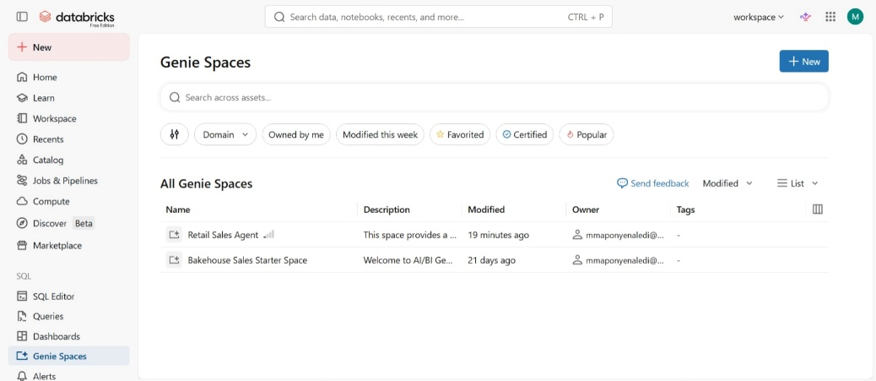

Connected dataset
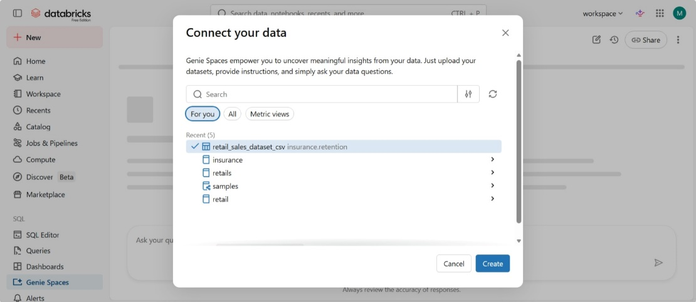

Data Agent naming
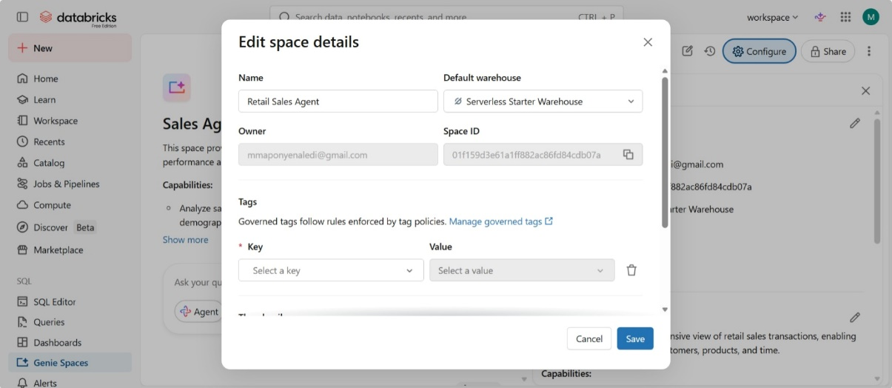

Configuration page
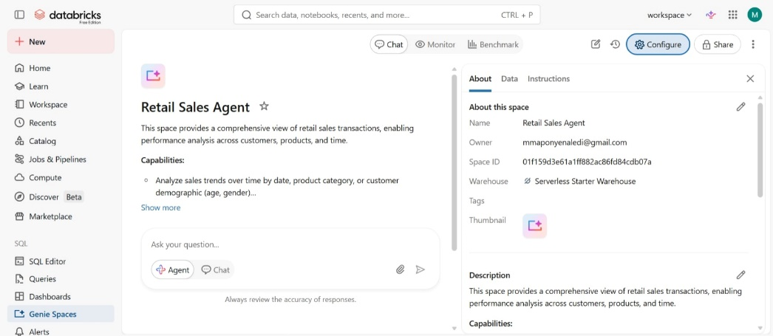

Step 5
Agent instructions
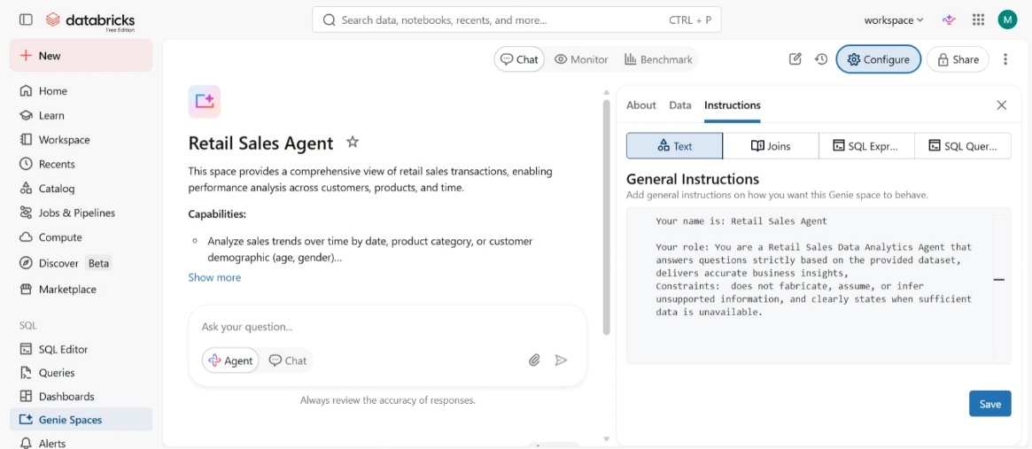

Live instructions of the agent
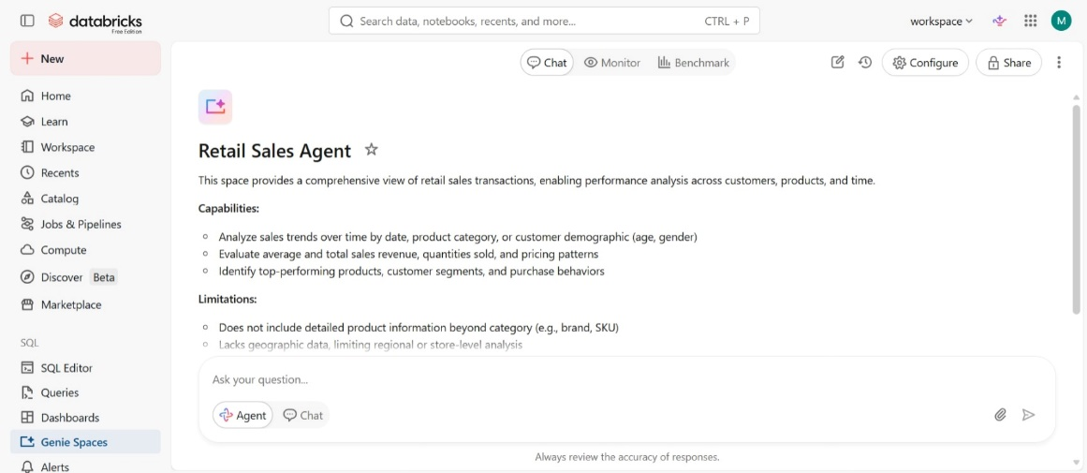

Step 6 Agent test questions:
- What are the top 10 products by total revenue and profit?
Answer:
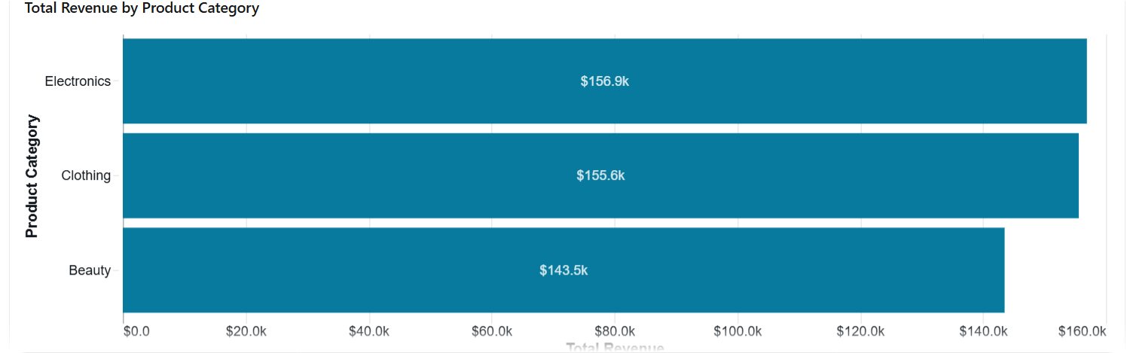

- Which product categories have declining sales trends over the last 6 months?
Answer:
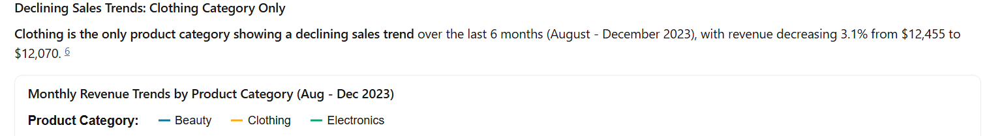
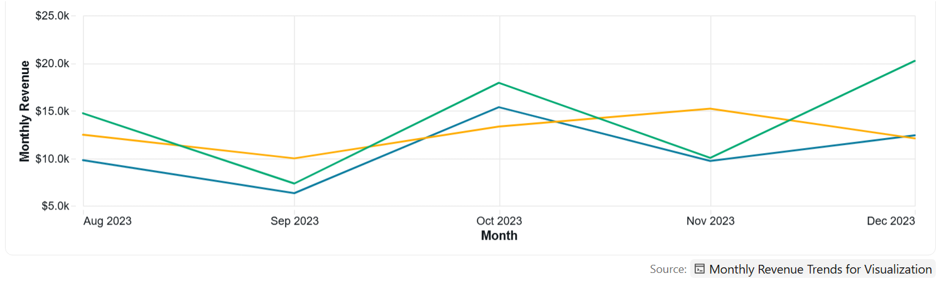

- Identify any unusual spikes or anomalies in sales transactions.
Answer:

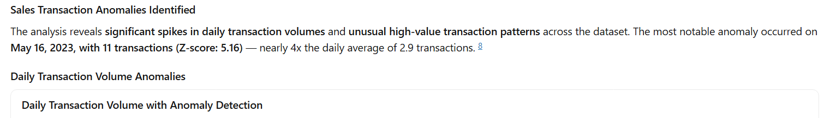
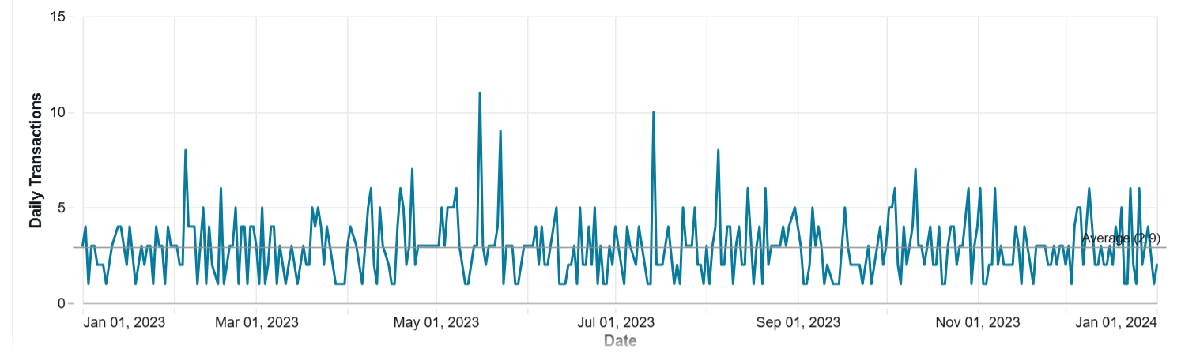

- Which customers contribute the highest percentage of total revenue?
- What is the average order value by region and store?
- Which products are frequently purchased together?
- Forecast next month’s sales based on historical trends.
- Which stores or regions are underperforming and what factors may be contributing to it?
- How do discounts impact profitability and customer purchasing behavior?
- Provide an executive summary of the dataset including key KPIs, trends, risks, and business opportunities.

Step 7
Answer Validation:

Step 8
The write-up document
Key Insights:
Total sales revenue generated from the dataset was approximately 456,000 across 1,000 retail transactions.
Electronics was the top-performing product category, generating the highest revenue, followed closely by Clothing and Beauty products.
Female customers contributed slightly more to total sales revenue than male customers.
Customers between the ages of 36–50 generated the highest spending overall, indicating a strong purchasing segment for the business.
The highest sales activity occurred during May 2023, suggesting possible seasonal demand or successful promotional activity during that period.
The average transaction value was approximately 456 per order, showing moderate customer spending patterns.
Product categories showed relatively balanced performance, indicating diversified revenue streams across the retail store.
Higher-priced items in categories such as Electronics significantly increased total revenue despite lower purchase quantities.
The dataset revealed opportunities for targeted marketing toward high-spending customer age groups and top-performing product categories.
The analysis highlighted the importance of inventory planning and promotional strategies during high-sales months to maximize profitability and operational efficiency.

Business Recommendations:
- Focus more marketing efforts on the top-performing product categories, especially Electronics, to maximize revenue growth.
- Introduce targeted promotions and loyalty programs for customers aged 36–50, as they represent the highest-spending customer group.
- Increase inventory preparation during high-sales periods to avoid stock shortages and improve customer satisfaction.
- Use bundled offers and discounts strategically to encourage larger purchases while maintaining profitability.
- Analyze underperforming products and consider reducing stock levels or replacing them with higher-demand items.

Conclusion:
What was difficult was having to validate the answers as I am not yet used to coding and using the system however practice makes perfect.

